Menstrual Hygiene Awareness in Adolescent Girls: Exploring the Influence of Maternal Education on Knowledge and Practices in a Sub-Urban Area of Pakistan
Supervisor: Dr Naureen Omar
Investigators: Dr Ayesha Javed, Dr Fatima Sohail

Abstract
Menstrual hygiene management remains an important adolescent health concern in low-resource settings, where stigma, limited menstrual health literacy, and inadequate access to safe hygiene materials may affect health, dignity, and school participation [1-3]. Although maternal education is often considered an influence on adolescent health behavior, evidence from sub-urban Pakistan remains limited. This study assessed menstrual hygiene knowledge and practices among adolescent girls and examined whether these outcomes varied across maternal education categories. The analysis used a finalized school-based survey dataset from a sub-urban area of Lahore, Pakistan. The SPSS source file contained 160 raw records; 40 fully blank trailing records were removed, resulting in an analytic sample of 120 participants. Knowledge scores ranged from 0 to 9 and practice scores from 0 to 7. Both were derived using archived questionnaire scoring rules, with one adjudicated correction, and missing questionnaire responses were assigned a score of zero. The analysis included descriptive statistics, data quality assessment, group comparisons, and correlations. Kruskal-Wallis tests were selected for the primary group comparisons because the scores were bounded and discrete and the maternal education groups were imbalanced. Participants had a mean age of 14.47 years (range 12-18 years). The mean knowledge score was 6.65/9 (SD 1.22), while the mean practice score was 5.68/7 (SD 0.58). Practice scores differed across maternal education groups at a nominal level before correction for multiple testing (Kruskal-Wallis H = 10.1562, unadjusted p = 0.0379, epsilon-squared = 0.0853), but the Holm-adjusted p-value was 0.0758. The omnibus comparison for knowledge was not statistically significant (H = 8.0427, p = 0.0900, epsilon-squared = 0.0676). Knowledge increased with age (r = 0.314, p = 0.0005), and knowledge and practice were positively correlated (r = 0.317, p = 0.0004). The post-processing issue-free cell rate was 88.70% overall and 99.70% after conditional and skip-logic variables were excluded. In the complete-case practice analysis, the group comparison was not statistically significant (p = 0.0705), indicating sensitivity to the missing-as-zero scoring rule. Thus, maternal education may be related to menstrual hygiene practice, but the evidence is exploratory and does not establish an independent or causal association. Interpretation is further limited by age-related confounding, pronounced group imbalance, the cross-sectional design, scoring limitations, and unresolved ethics documentation.
Keywords: menstrual hygiene; adolescent girls; maternal education; Pakistan; school health; cross-sectional study

1. Introduction
Adolescence is a formative period during which health-related attitudes and behaviors emerge and may continue into adulthood. Menstrual health is integral to adolescent well-being, particularly for girls managing menarche, menstrual cycles, personal hygiene, and social stigma in settings where reliable information and material support may be scarce. Guidance from the World Health Organization and UNESCO places menstrual health at the intersection of health, education, rights, and gender equity. This perspective recognizes that effective menstrual health management requires not only hygiene materials, but also accurate knowledge, supportive social norms, and safe sanitation facilities [1-3].
Across many low- and middle-income settings, menstrual hygiene management is constrained by cultural taboos, limited privacy, restricted access to appropriate absorbents and disposal facilities, and reluctance to discuss menstruation openly. Some girls reach menarche without prior preparation and must depend on informal or incomplete information. Such conditions may undermine hygienic practices, cause discomfort or embarrassment, and restrict school attendance and social participation. Studies from Ghana, Ethiopia, Nepal, India, and comparable settings indicate that menstrual knowledge and practice are associated with parental education, information access, and wider socioeconomic circumstances [4-10].
These relationships are especially pertinent in Pakistan. Sub-urban communities may encompass considerable variation in educational attainment, household resources, and social norms, making the interplay between family context, maternal education, and menstrual hygiene behavior particularly relevant. A mother's education could shape her daughter's menstrual hygiene through communication, supervision, the modeling of hygienic routines, and support in obtaining menstrual products. Nevertheless, higher maternal education may not produce substantial differences in formal menstrual knowledge when girls also learn from school, peers, or media. Against this background, the present study assessed menstrual hygiene knowledge and practices among adolescent girls in a sub-urban area of Lahore, Pakistan, focusing on variation across maternal education categories.

2. Rationale and Objectives
The analysis was designed to address a practical public health question: is maternal education more closely related to adolescent girls' knowledge of menstruation or to their practices during menstruation? The distinction matters because greater awareness may not lead to behavioral change when household circumstances, product availability, or sanitation facilities limit what girls can do. The primary objectives were therefore to assess menstrual hygiene knowledge and practice scores and determine whether either outcome differed by maternal education level. Secondary objectives included describing the sample's demographic profile and household economic characteristics and examining correlations among age, income, family size, and menstrual hygiene scores.

3. Methods

3.1 Study design, setting, and source protocol
This manuscript presents a structured secondary analysis of the finalized survey dataset available in the project workspace. The source protocol recorded in doc.md describes a school-based questionnaire study planned over nine months, from March to December 2024, at Reach School on Sau Asal Road, Lahore. It specified recruitment within the school, administration of a structured questionnaire through interviews conducted by the primary investigators, and an anticipated interview duration of approximately 15 to 20 minutes for each participant.

3.2 Participant selection and analytic sample
According to the source protocol, adolescent girls were eligible when parental consent had been obtained. Students without parental consent, as well as those unwilling to participate, were to be excluded. The protocol further specified simple random sampling by lottery from a prepared list of eligible female students. During final data processing, 160 raw records were loaded from the SPSS source file. Forty fully blank trailing records were removed, leaving 120 valid participant records in the analytic sample.

3.3 Study variables
Menstrual hygiene knowledge and menstrual hygiene practice were the two principal outcomes. The knowledge score was a bounded discrete measure ranging from 0 to 9; the corresponding practice score ranged from 0 to 7. Maternal education was the primary explanatory variable and followed the coding in the SPSS metadata: 1 = Illiterate, 2 = Primary, 3 = Middle, 4 = Secondary, and 5 = Intermediate and above. Other variables used for descriptive or exploratory analyses were age, paternal education, maternal occupation, paternal occupation, monthly household income, family size, and per-capita income.

3.4 Scoring rules and derived variables
The knowledge score was derived from the Section III questionnaire items according to the archived scoring protocol, apart from one adjudicated correction. In the archived key, a point for the menstruation-process item was assigned to code 2, whereas the SPSS metadata labeled code 1 as physiological/natural and code 2 as pathological/disease. Since menstruation is a physiological rather than pathological process, the corrected primary analysis awarded the point to code 1. Results based on the original coding were retained for sensitivity analysis and as an audit record.
Practice scores were calculated from the Section IV items using the archived scoring scheme. Missing responses and responses outside the labeled domains were scored as zero under the implemented rules. In four archived score items, every listed response option received one point: the absorbent and change-frequency items in both the knowledge and practice sections. Although these items contributed to the totals, they did not distinguish among participants. Per-capita income was calculated by dividing monthly household income by the total number of family members. The value was set to null rather than imputed when household income or family size was missing, or when family size was zero.

3.5 Data quality procedures
A dedicated data quality report was produced to quantify missing observations, categorical responses outside their labeled domains, and the proportions of affected rows and columns. Categorical data were checked against the value domains retained in the SPSS metadata. Because several questionnaire variables were conditional follow-up items, overall data quality was distinguished from core data quality so that expected skip-pattern missingness would not be interpreted as poor data capture. A separate consistency check compared reported total family size with the sum of male and female family members.

3.6 Statistical analysis
All statistical tests used a two-sided significance threshold of 0.05. Categorical variables were summarized using counts and percentages. Continuous variables were described by the mean, median, standard deviation, minimum, maximum, and quartiles. Knowledge and practice scores were the two principal outcomes. Before group comparisons were selected, Shapiro-Wilk tests were used to assess within-group normality when group size allowed, Levene's test was used to examine variance homogeneity where feasible, and small group sizes were identified as a potential threat to parametric assumptions. Because both outcomes were bounded and discrete and the maternal education groups were markedly imbalanced, the primary comparisons used Kruskal-Wallis tests. Epsilon-squared was reported as the effect size. Unadjusted p-values are presented as the primary results, with Holm correction across the two outcomes used to evaluate familywise robustness.
Linear relationships among age, income, family size, per-capita income, knowledge, practice, and total score were examined using Pearson complete-case correlations. These secondary analyses were exploratory and were not corrected for multiple testing. Given the marked right-skew and susceptibility to outliers in income, Spearman rank correlations were calculated as sensitivity analyses. Further sensitivity checks repeated the Kruskal-Wallis comparisons after excluding the highest maternal education category, treated maternal education as an ordinal rank, tested whether age varied across maternal education groups, and repeated the analysis using the archived scoring key.

3.7 Ethical considerations
The source protocol indicated that parental consent, confidentiality, anonymity, school permission, and institutional review were planned. Their completion cannot be verified from the archived analysis bundle. No reportable ethics approval identifier is present, and the appended consent language relates to bullying rather than menstrual hygiene. Before submission, the study-specific consent form and ethics record must therefore be located and confirmed. No claim of ethics approval or valid consent is made where the available archive does not support it.

4. Results

4.1 Participant flow
The finalized SPSS file contained 160 raw records. Removal of 40 fully blank trailing records left 120 participant records for analysis. The analytic flow is shown in Table 1.
Stage | n
Raw records loaded | 160
Removed (fully blank trailing records) | 40
Final records analyzed | 120

4.2 Demographic and household characteristics
Participants were, on average, 14.47 years old (SD 1.40), with an age range of 12 to 18 years. Monthly household income varied widely. Its mean was 48,833.33, and the highest reported value was 600,000, a pattern consistent with substantial right-skew. Mean family size was 6.66 members, and mean per-capita income was 8,648.83. Most participants were in the lower maternal education categories: 71.7% had mothers classified as illiterate and 14.2% had mothers with primary education. The Intermediate and above category contained only one participant. Full demographic and household characteristics are reported in Table 2.
Variable | Category/Statistic | Value
Age (years) | Mean +/- SD | 14.47 +/- 1.40
Age (years) | Median (IQR) | 14.0 (13.0-15.0)
Age (years) | Range | 12-18
Monthly income | Mean +/- SD | 48,833.33 +/- 57,440.99
Monthly income | Median (IQR) | 45,000 (30,000-50,000)
Family size | Mean +/- SD | 6.66 +/- 2.38
Family size | Median (IQR) | 6 (5-8)
Per-capita income | Mean +/- SD | 8,648.83 +/- 10,763.62
Per-capita income | Median (IQR) | 6,428.57 (4,285.71-10,000)
Maternal education | Illiterate | 86 (71.7%)
Maternal education | Primary | 17 (14.2%)
Maternal education | Middle | 8 (6.7%)
Maternal education | Secondary | 8 (6.7%)
Maternal education | Intermediate and above | 1 (0.8%)
Maternal occupation | Non-working | 103 (85.8%)
Maternal occupation | Working | 14 (11.7%)
Maternal occupation | Other/unlabeled code | 3 (2.5%)
Paternal education | Primary | 35 (29.2%)
Paternal education | Middle | 28 (23.3%)
Paternal education | Secondary | 24 (20.0%)
Paternal education | Illiterate | 24 (20.0%)
Paternal education | Intermediate and above | 9 (7.5%)

4.3 Knowledge and practice score distributions
Knowledge scores extended from 3 to 9, with a mean of 6.65 and a median of 7.00. Practice scores were more narrowly distributed, ranging from 4 to 7, with a mean of 5.68 and a median of 6.00. A knowledge score of 7 was the most frequent value, observed in 37.5% of participants. For practice, the modal score was 6, recorded for 71.7% of the sample. Table 3 summarizes both distributions.
Score domain | Summary
Knowledge score (0-9) | Mean 6.65, Median 7.00, SD 1.22, Min 3, Max 9
Practice score (0-7) | Mean 5.68, Median 6.00, SD 0.58, Min 4, Max 7

The distributions of the two scores are displayed in Figure 1.

4.4 Scores by maternal education
Group-level summaries suggested modest increases in average scores at higher levels of maternal education. Interpretation of this pattern is limited, however, by the pronounced imbalance between groups and particularly by the single observation in the highest category. Mean knowledge scores were 6.53 in both the illiterate and primary groups and 8.00 in the Intermediate and above group. Mean practice scores ranged from 5.59 among participants whose mothers were classified as illiterate to 6.12 in the secondary education group. Table 4 gives the complete groupwise summary.
Maternal education level | n | Knowledge mean +/- SD | Knowledge median (IQR) | Practice mean +/- SD | Practice median (IQR)
Illiterate | 86 | 6.53 +/- 1.27 | 7.0 (6.0-7.0) | 5.59 +/- 0.62 | 6.0 (5.0-6.0)
Primary | 17 | 6.53 +/- 1.23 | 7.0 (7.0-7.0) | 5.76 +/- 0.44 | 6.0 (6.0-6.0)
Middle | 8 | 7.38 +/- 0.52 | 7.0 (7.0-8.0) | 6.00 +/- 0.00 | 6.0 (6.0-6.0)
Secondary | 8 | 7.25 +/- 0.71 | 7.0 (7.0-8.0) | 6.12 +/- 0.35 | 6.0 (6.0-6.0)
Intermediate and above | 1 | 8.00 | 8.0 (8.0-8.0) | 6.00 | 6.0 (6.0-6.0)

Figures 2 and 3 present these patterns as bar plots with error bars and as box plots, respectively.

4.5 Inferential analysis for maternal education
The assumption checks did not support parametric comparisons across the maternal education groups, so Kruskal-Wallis tests were used for both outcomes. The omnibus comparison of knowledge scores was not statistically significant (H = 8.0427, unadjusted p = 0.0900, epsilon-squared = 0.0676). For practice, the unadjusted comparison was nominally significant (H = 10.1562, unadjusted p = 0.0379, epsilon-squared = 0.0853), but this result did not remain below 0.05 after correction across the two outcomes (Holm-adjusted p = 0.0758). The practice finding is consequently exploratory rather than robust to familywise error control. Moreover, significance for one outcome and non-significance for the other do not, by themselves, demonstrate that the underlying associations differ. Table 5 reports these results.
Outcome | Test | Statistic | p-value | Effect size (epsilon-squared) | Interpretation
Knowledge score | Kruskal-Wallis | H = 8.0427 | 0.0900 | 0.0676 | Omnibus comparison not statistically significant
Practice score | Kruskal-Wallis | H = 10.1562 | 0.0379 | 0.0853 | Nominal p < 0.05; Holm-adjusted p = 0.0758

4.6 Correlation analysis
In the Pearson complete-case analysis, age was positively correlated with knowledge (r = 0.314, p = 0.0005) and practice (r = 0.267, p = 0.0032). Knowledge and practice were also positively correlated (r = 0.317, p = 0.0004). Family size had a negative correlation with knowledge (r = -0.201, p = 0.0279). Neither monthly household income nor per-capita income was significantly correlated with either score in the Pearson analysis. Since multiple correlations were examined without multiplicity correction, these secondary findings remain exploratory. Correlations with total score were not interpreted because total score was mathematically derived from the knowledge and practice components. The score-related correlations appear in Table 6.
Variable pair | r | p-value | Interpretation
Age vs Knowledge score | 0.314 | 0.0005 | Moderate positive association
Knowledge score vs Practice score | 0.317 | 0.0004 | Weak-to-moderate positive association
Age vs Practice score | 0.267 | 0.0032 | Weak positive association
Family size vs Knowledge score | -0.201 | 0.0279 | Weak negative association
Family size vs Practice score | -0.165 | 0.0725 | Not significant
Income vs Knowledge score | -0.042 | 0.6501 | Not significant
Income vs Practice score | -0.122 | 0.1834 | Not significant
Per-capita income vs Knowledge score | 0.040 | 0.6637 | Not significant
Per-capita income vs Practice score | -0.077 | 0.4040 | Not significant

Figure 4 shows the relationships among the continuous variables in a scatter matrix.

4.7 Data quality and sensitivity analyses
Following data processing, 550 cells were missing and six categorical responses fell outside their labeled domains. These occurred among 4,920 cells in the transformed 41-column dataset, corresponding to overall issue-free cell rate of 88.70%. The denominator includes optional free-text variables and five derived fields. The six out-of-label observations consisted of three maternal-occupation values coded 3, two menstruation-process values coded 5, and one handwashing value coded 3. Once conditional and skip-logic variables were excluded, core issue-free cell rate was 99.70%. No inconsistency was found between total family size and the sum of reported male and female family members.
Excluding the one participant in the highest maternal education group did not materially alter the knowledge result (H = 6.3719, p = 0.0949, epsilon-squared = 0.0540). The unadjusted practice comparison remained below 0.05 (H = 9.7515, p = 0.0208, epsilon-squared = 0.0826). However, when practice analysis was restricted to the 115 participants with complete responses for all seven practice items, the result was not statistically significant (H = 8.6488, p = 0.0705). The nominally significant primary practice finding was therefore sensitive to the archived rule that scored missing responses as zero.
When maternal education was treated as an ordinal variable, it was positively correlated with knowledge (rho = 0.2023, p = 0.0267) and practice (rho = 0.2684, p = 0.0030). These trend analyses were exploratory and not adjusted for multiplicity. Age also differed across maternal education groups (H = 10.6913, p = 0.0303), leaving age as a plausible confounder. The Spearman analyses retained positive associations between age and knowledge (rho = 0.3710, p < 0.001) and between knowledge and practice (rho = 0.3650, p < 0.001). In contrast to the Pearson result, the rank-based analysis found a weak positive association between income and knowledge (rho = 0.2160, p = 0.0178), while income remained unrelated to practice. Reinstating the archived pathological-response scoring key reduced the mean knowledge score to 5.82, but the omnibus comparison remained non-significant (H = 5.8669, p = 0.2093, epsilon-squared = 0.0493). Table 7 presents the sensitivity analyses in full.
Sensitivity analysis | Knowledge result | Practice result | Interpretation
Excluding maternal education level 5 (n = 1) | H = 6.3719, p = 0.0949, epsilon-squared = 0.0540 | H = 9.7515, p = 0.0208, epsilon-squared = 0.0826 | Unadjusted practice p remains below 0.05; knowledge remains non-significant
Complete practice responses only | Unchanged | H = 8.6488, p = 0.0705, epsilon-squared = 0.0759; n = 115 | Practice result is sensitive to missing-response handling
Maternal education treated as ordinal | rho = 0.2023, p = 0.0267 | rho = 0.2684, p = 0.0030 | Exploratory monotonic trends; unadjusted for multiplicity
Age across maternal-education groups | H = 10.6913, p = 0.0303 | - | Age is a plausible confounder
Archived pathological-response scoring key | Mean 5.82; H = 5.8669, p = 0.2093, epsilon-squared = 0.0493 | Unchanged | Main significance classification is unchanged
Spearman rank correlation (age-knowledge) | rho = 0.3710, p < 0.001 | - | Positive association remains
Spearman rank correlation (knowledge-practice) | rho = 0.3650, p < 0.001 | - | Positive association remains
Spearman rank correlation (income-knowledge / income-practice) | rho = 0.2160, p = 0.0178 | rho = 0.0544, p = 0.5550 | Weak income-knowledge association appears only in the rank-based analysis

5. Figures

Figure 1. Distribution of knowledge and practice scores
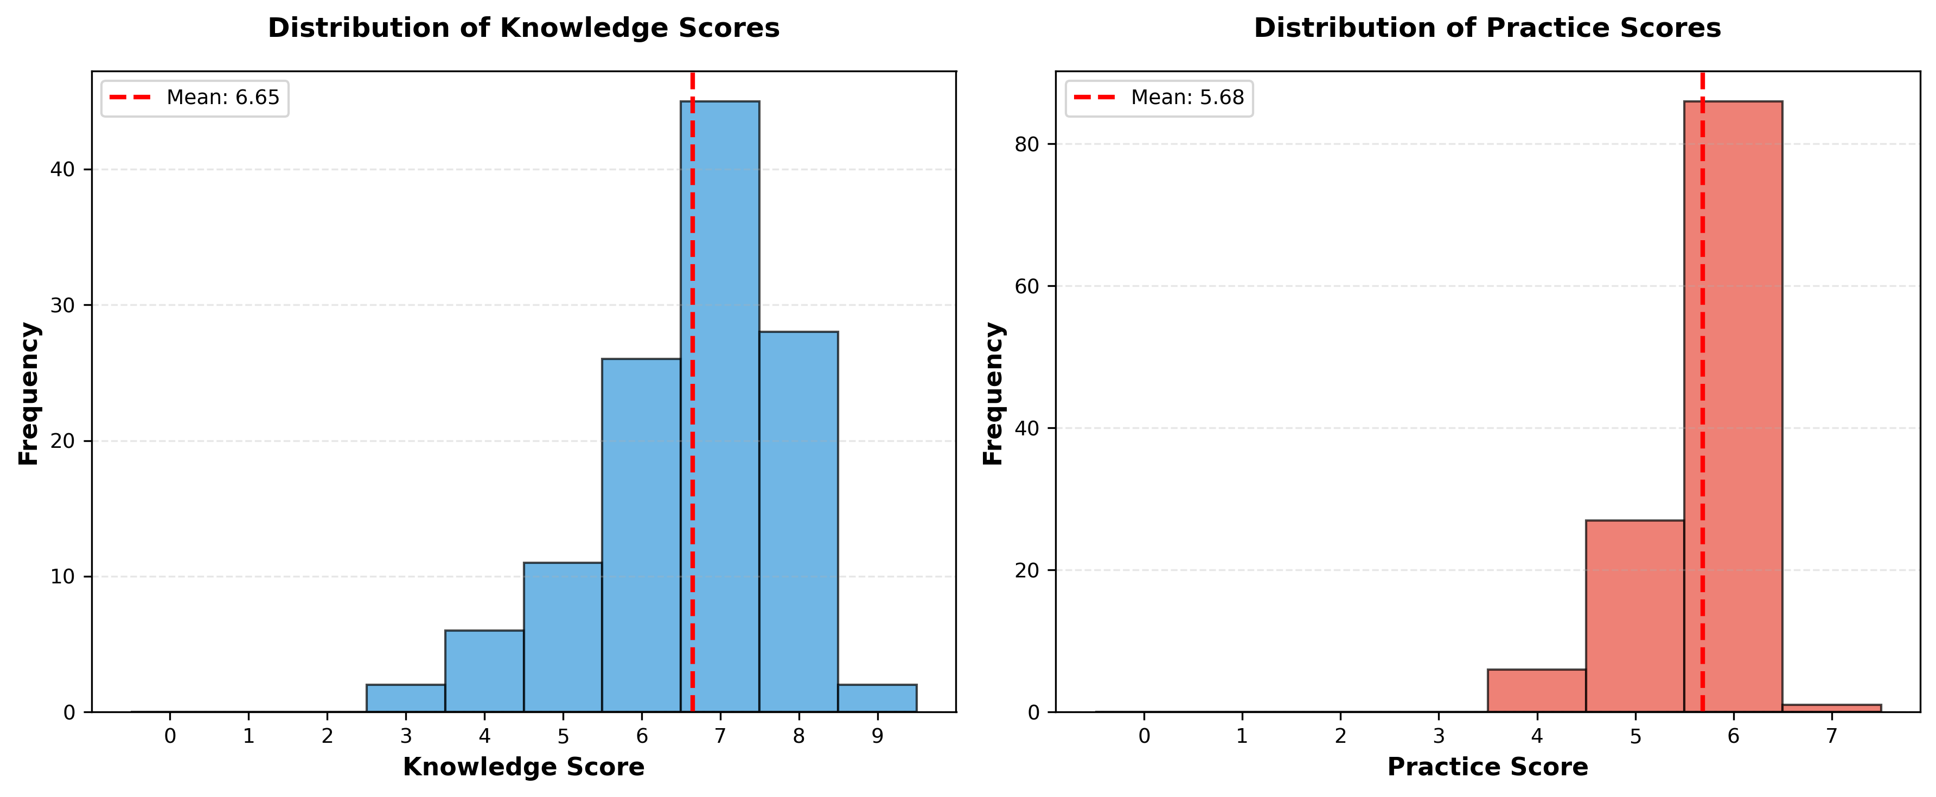
Figure 1. Knowledge and practice score distributions.

Figure 2. Mean knowledge and practice scores by maternal education level
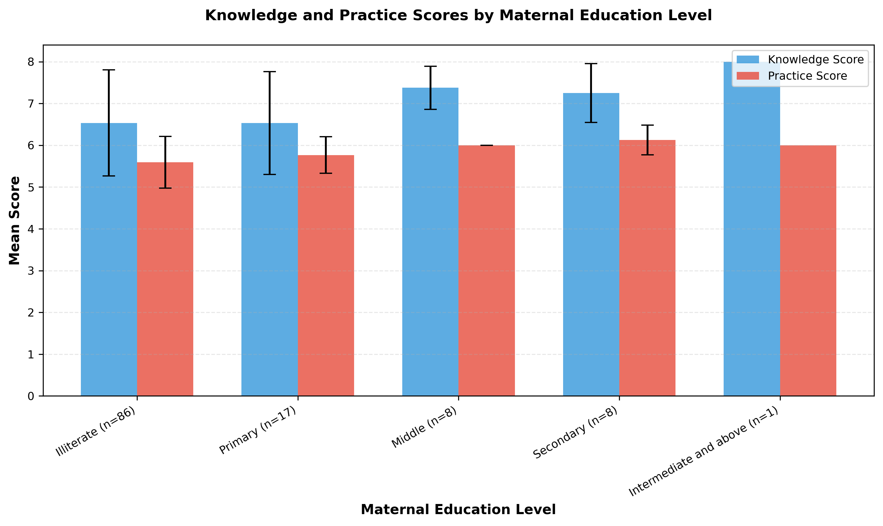
Figure 2. Mean knowledge and practice scores by maternal education level.

Figure 3. Boxplots of knowledge and practice scores by maternal education level
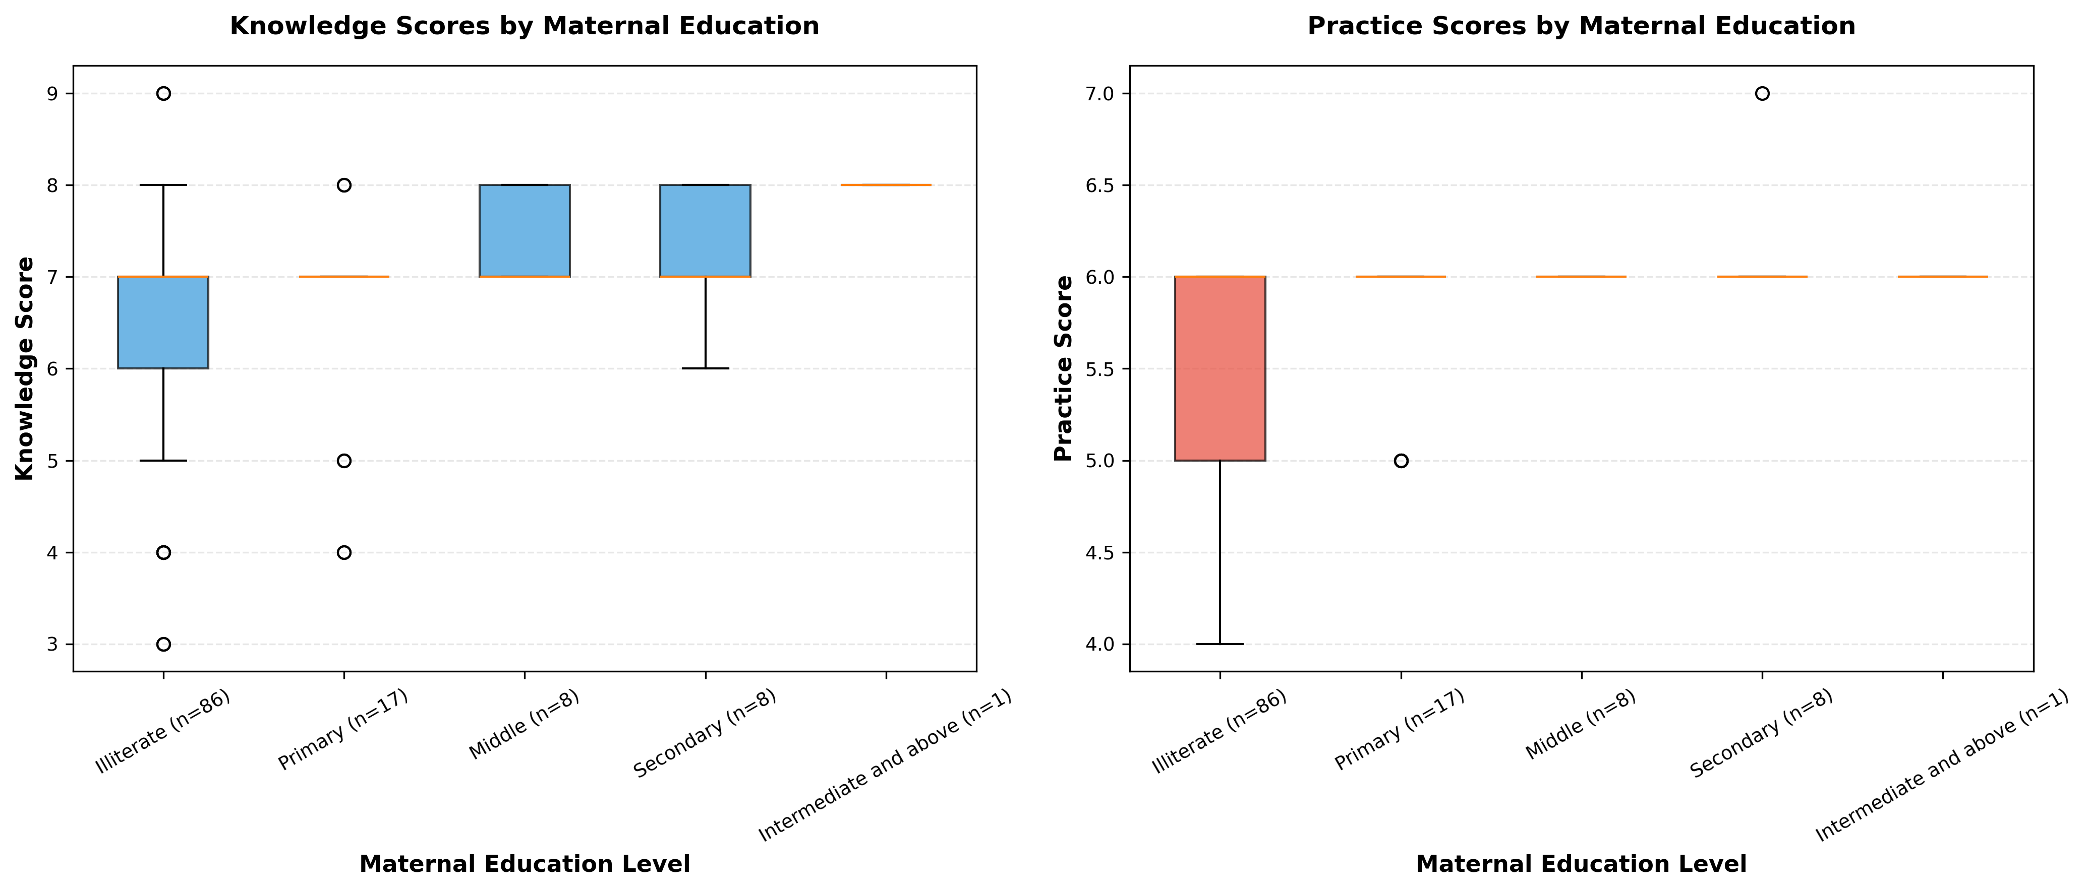
Figure 3. Boxplot comparison by maternal education level.

Figure 4. Scatter matrix of continuous variables
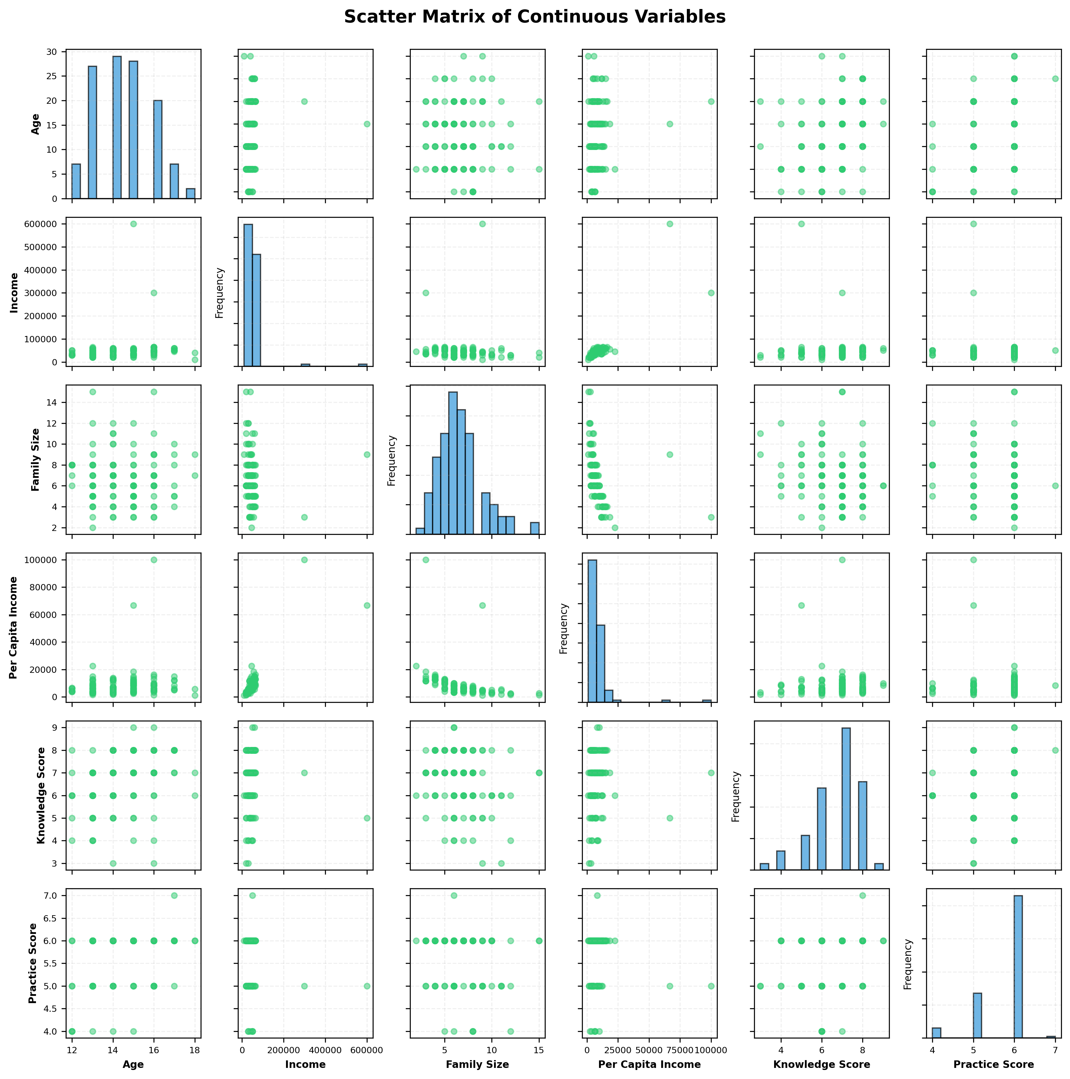
Figure 4. Scatter matrix for age, income, family size, per-capita income, knowledge, practice, and total score.

6. Discussion
Practice scores showed a nominally significant unadjusted difference across maternal education groups, whereas the omnibus comparison for knowledge was not statistically significant. This practice result did not remain below 0.05 after Holm correction for the two principal outcomes. Nor was there a formal test comparing the strength of the associations for knowledge and practice. It should therefore be read as an exploratory finding. Household routines, supervision, access to menstrual products, and age may all contribute to the observed pattern, but the present unadjusted analysis cannot separate these possible explanations.
The positive association between age and knowledge is compatible with a developmental process. Older adolescents have generally had more opportunities to experience menstruation, discuss it with relatives or peers, and develop their understanding of cycle management. Knowledge was also positively related to practice. The magnitude of this correlation, however, does not support an assumption that knowledge is automatically translated into behavior. In menstrual hygiene research, stigma, material constraints, and structural barriers may all modify the relationship between understanding and practice.

6.1 Comparative review methods
The findings were contextualized through a structured comparative review of PubMed and OpenAlex. Searches focused on primary studies addressing menstrual hygiene knowledge and practice among adolescents, maternal or parental education, and enabling resources. Studies from Pakistan were prioritized, followed by research from elsewhere in South Asia and a contextual Ethiopian study that reported directly comparable adjusted models for maternal education. DOI identities were verified through Crossref and the DOI Handle service. Twelve primary studies were included in the final comparison: five from Pakistan, six from other South Asian settings, and one from Ethiopia. Complete full texts were reviewed for 11 studies. For one Nepalese study, only the publisher abstract was available because the article PDF could not be obtained. The studies differed in instruments, thresholds, populations, and definitions of “good” knowledge or practice; accordingly, no pooled estimate was calculated and nominal percentages were not ranked directly.

6.2 Comparison with published studies
Study | Main comparable finding | Relationship to the present study
Wasan et al., rural Sindh [11] | Only 25% of 25,305 participants used materials classified as appropriate; no participant education versus higher secondary/university predicted inappropriate material use (OR 3.90, 95% CI 3.36-4.52). | Supports an education-practice pathway and a strong role for material access, but measured the participant's education rather than maternal education.
Aziz et al., Khairpur, Sindh [12] | Satisfactory knowledge was 69.8% in the urban school and 38.4% in the rural school; good practice was 71.1% and 11.9%, respectively. Mothers were the main information source in both groups. | Demonstrates major contextual variation within Pakistan but did not test maternal education against outcomes.
Shah et al., Ghizer, Pakistan [13] | Among 300 girls, 51.7% lacked awareness at menarche, 47.7% used reusable cloth/towels, and 30.7% used disposable pads; 65.3% of mothers had no education. | Supports a maternal information pathway, but maternal education was discussed rather than statistically tested.
Michael et al., Quetta, Pakistan [14] | Mothers were the main information source for 67%; 77.7% had received no school menstrual-education session; 68.7% used commercial pads. | Reinforces reliance on maternal information while showing that knowledge and product use can diverge.
Afzaal et al., rural Lahore [15] | Knowledge and practice were positively correlated (r = 0.649, p < 0.001). | The closest geographic comparator agrees with the present positive knowledge-practice correlation, but did not report a maternal-education association.
Dasgupta and Sarkar, rural India [16] | Although 48.75% knew sanitary pads were appropriate, only 11.25% used them. | Shows that knowledge does not ensure practice.
Kansal et al., rural India [17] | Girls with literate mothers used pads more often than girls with illiterate mothers (62% vs 13%); the association was significant. | Directly agrees with the direction of the present maternal-education/practice finding, although hygiene definitions differed.
Yadav et al., Nepal [18] | Most respondents had fair or good knowledge, but only 40% of girls met the study's good-practice definition. | Supports separate assessment of knowledge and practice.
Bhusal, Nepal [7] | Literate mothers were associated with lower adjusted odds of good practice (AOR 0.52, 95% CI 0.30-0.88), while literate fathers had higher odds. | Contradicts the expected direction and shows that maternal education is not a universal stand-alone proxy for a supportive menstrual environment.
Haque et al., Bangladesh [19] | After an uncontrolled six-month school intervention, high knowledge increased from 51.0% to 82.4% and good practice from 28.8% to 88.9%. | Supports intervention feasibility, but the design cannot establish that education alone caused or sustained the changes.
Alam et al., Bangladesh [20] | Accessible girls' toilets were associated with less menstrual-related absence (adjusted prevalence difference -5.4 percentage points, 95% CI -10 to -1.6); restrictions were associated with more absence. | Shows that facilities and social rules can shape behavior independently of knowledge or maternal schooling.
Upashe et al., Ethiopia [21] | Maternal secondary-or-higher education predicted good knowledge (AOR 1.51, 95% CI 1.02-2.22) and good practice (AOR 2.03, 95% CI 1.38-2.97). | Agrees with the present practice association but differs by also finding a knowledge association.

The direction of the present practice result is consistent with the findings of Kansal et al. and Upashe et al. [17,21]. Bhusal's inverse adjusted association, however, demonstrates that this direction is not consistent across settings [7]. The absence of a statistically significant knowledge association in the present analysis also contrasts with Upashe et al. [21]. Direct numerical comparisons would be inappropriate because the studies differ in outcome definitions, participant ages, maternal education categories, adjustment for confounders, and social context. The current study analyzed bounded continuous scores using unadjusted group comparisons, while several comparison studies dichotomized outcomes according to study-specific thresholds and used multivariable logistic regression.
Research from Pakistan repeatedly identifies mothers as a major source of menstrual information [12-14], yet most studies have not estimated whether maternal education independently predicts knowledge or practice. The present analysis offers a direct local comparison without assuming that frequent communication with mothers necessarily provides accurate information. The positive relationship between knowledge and practice is consistent with findings from rural Lahore [15]. Evidence from Nepal and India similarly shows why the two outcomes must be examined separately: relatively adequate knowledge may coexist with less adequate practice [16,18].
The wider literature helps explain why menstrual knowledge and practice are not interchangeable. The affordability and availability of products, household resources, privacy, sanitation, school infrastructure, and social restrictions may either enable or prevent hygienic behavior [11,20]. Some practices may also be learned and maintained through routine socialization even when formal knowledge is incomplete. Maternal education could therefore operate through communication, supervision, purchasing capacity, and household norms rather than through education alone.
Several features strengthen the analysis. The reproducible workflow preserved timestamped outputs and incorporated explicit data quality reporting, documented checks of analytical assumptions, and effect sizes alongside p-values. It also tested the internal consistency of family-size data. Targeted sensitivity analyses established that the general conclusions were unchanged after removing the single participant in the highest education stratum and when rank-based correlation methods were used.
The limitations are substantial and should frame interpretation. The cross-sectional design permits conclusions about association, not causation. Analyses were bivariate and unadjusted; age varied across maternal education groups and may confound the observed relationship, while school conditions, menstrual product access, and other household factors were not controlled. The nominal practice result did not survive Holm correction for the two principal outcomes. Maternal education groups were also highly imbalanced, especially at the uppermost level, reducing precision and making detailed group comparisons unstable. In addition, the omnibus test does not establish which groups differ.
Measurement and data-handling issues introduce further uncertainty. Assigning zero to missing or invalid questionnaire responses may have lowered scores when a missing response did not reflect poor knowledge or practice. Four items were nondiscriminating because every listed response option received one point, limiting construct validity and increasing the apparent proportion of the maximum score. One knowledge item required post hoc adjudication after the archived key was found to conflict with the biological meaning of the labeled responses, and six responses lay outside their SPSS value-label domains. Secondary correlations and ordinal trend tests were exploratory and were not corrected for multiple comparisons. Finally, because all participants came from one school, the results may not generalize to other adolescent populations in Lahore or elsewhere in Pakistan.
These findings suggest that menstrual health programs in similar settings should extend beyond the delivery of factual information. Behavior-focused assistance, involvement of caregivers, and practical support for product access, privacy, and safe disposal may all be relevant. Future studies would benefit from larger samples with better representation across education categories, validated scoring instruments, and explicitly adjusted multivariable models. Prospective or mixed-methods designs could also help identify the pathways through which maternal education relates to menstrual hygiene behavior.

7. Conclusion
Among adolescent girls in this sub-urban Lahore sample, practice scores differed across maternal education groups at the unadjusted 0.05 threshold, whereas the omnibus knowledge comparison did not. The practice association was only nominally significant in the unadjusted analysis: its Holm-adjusted p-value was 0.0758, and the complete-case sensitivity analysis gave p = 0.0705. Age may also confound the group differences. Exploratory analyses found positive correlations among older age, knowledge, and practice. These cross-sectional observations are hypothesis-generating and should not be interpreted as causal evidence. Firm conclusions about the independent contribution of maternal education will require larger and more balanced studies, validated scoring methods, documented ethics procedures, and adjusted analyses.

8. Declarations

Ethics statement
The source protocol planned parental consent, confidentiality, anonymity, school permission, and institutional review. The archived record, however, provides neither a reportable ethics approval identifier nor a valid consent form specific to menstrual hygiene; the appended consent language concerns bullying. Ethics approval and consent therefore cannot be confirmed from the available materials. This documentation must be resolved before the manuscript is submitted.

Funding
The analysis bundle contained no information indicating external funding.

Competing interests
No competing interests were declared in the source materials available for review.

Data and materials availability
This manuscript was prepared from corrected analysis outputs in output/analysis_20260712_224950/. The archived materials did not include public repository details; these should be supplied if required by the target journal.

Author contributions
The title page identifies the supervisor and investigators. Statistical processing and manuscript preparation followed the documented local analysis workflow.

9. References
- World Health Organization. Strengthening the health sector response to adolescent health and development. Geneva: WHO; 2010. Available from: https://apps.who.int/iris/bitstream/handle/10665/340531/WHO-FCH-CAH-10-01-eng.pdf?sequence=1&isAllowed=y (No DOI; accessed 2026-03-19).
- World Health Organization. WHO statement on menstrual health and rights. 22 June 2022. Available from: https://www.who.int/news/item/22-06-2022-who-statement-on-menstrual-health-and-rights (No DOI; accessed 2026-03-19).
- UNESCO. Puberty and menstrual hygiene management. Available from: https://www.unesco.org/en/health-education/puberty (No DOI; accessed 2026-03-19).
- Kumbeni MT, Otupiri E, Ziba FA. Menstrual hygiene among adolescent girls in junior high schools in rural Northern Ghana. Pan Afr Med J. 2020;37:190. https://doi.org/10.11604/pamj.2020.37.190.19015
- Sahiledengle B, Atlaw D, Kumie A, Tekalegn Y, Woldeyohannes D, Agho KE. Menstrual hygiene practice among adolescent girls in Ethiopia: a systematic review and meta-analysis. PLoS One. 2022;17(1):e0262295. https://doi.org/10.1371/journal.pone.0262295
- Belayneh Z, Mekuriaw B. Knowledge and menstrual hygiene practice among adolescent schoolgirls in southern Ethiopia: a cross-sectional study. BMC Public Health. 2019;19(1):1595. https://doi.org/10.1186/s12889-019-7973-9
- Bhusal CK. Practice of menstrual hygiene and associated factors among adolescent school girls in Dang District, Nepal. Adv Prev Med. 2020;2020:1292070. https://doi.org/10.1155/2020/1292070
- Bhusal CK, Bhattarai S, Kafle R, Shrestha R, Chhetri P, Adhikari K. Level and associated factors of knowledge regarding menstrual hygiene among school-going adolescent girls in Dang District, Nepal. Adv Prev Med. 2020;2020:8872119. https://doi.org/10.1155/2020/8872119
- Sonowal P, Talukdar K, Saikia H. Sociodemographic factors and their association with menstrual hygiene practices among adolescent girls in urban slums of Dibrugarh town, Assam. J Family Med Prim Care. 2021;10(12):4446-4451. https://doi.org/10.4103/jfmpc.jfmpc_703_21
- Srivastava U, Singh KK. Exploring knowledge and perceptions of school adolescents regarding pubertal changes and reproductive health. Indian J Youth Adolesc Health. 2017;4(1):26-35. https://doi.org/10.24321/2349.2880.201705
- Wasan Y, Baxter J-AB, Rizvi A, Shaheen F, Junejo Q, Abro MA, et al. Practices and predictors of menstrual hygiene management material use among adolescent and young women in rural Pakistan: a cross-sectional assessment. J Glob Health. 2022;12:04059. https://doi.org/10.7189/jogh.12.04059
- Aziz A, Memon S, Aziz F, Memon F, Khowaja BMH, Zafar SN. A comparative study of the knowledge and practices related to menstrual hygiene among adolescent girls in urban and rural areas of Sindh, Pakistan: a cross-sectional study. Womens Health (Lond). 2024;20:17455057241231420. https://doi.org/10.1177/17455057241231420
- Shah SF, Punjani NS, Rizvi SN, Sheikh SS, Jan R. Knowledge, attitudes, and practices regarding menstrual hygiene among girls in Ghizer, Gilgit, Pakistan. Int J Environ Res Public Health. 2023;20(14):6424. https://doi.org/10.3390/ijerph20146424
- Michael J, Iqbal Q, Haider S, Khalid A, Haque N, Ishaq R, et al. Knowledge and practice of adolescent females about menstruation and menstruation hygiene visiting a public healthcare institute of Quetta, Pakistan. BMC Womens Health. 2020;20(1):4. https://doi.org/10.1186/s12905-019-0874-3
- Afzaal SS, Baloch S, Tahir S, Javed H, Saeed A, Pal MHA, et al. Awareness and practices of menstrual hygiene among rural adolescent schoolgirls in Lahore, Pakistan: a cross-sectional study. Cureus. 2024;16(11):e73899. https://doi.org/10.7759/cureus.73899
- Dasgupta A, Sarkar M. Menstrual hygiene: how hygienic is the adolescent girl? Indian J Community Med. 2008;33(2):77-80. https://doi.org/10.4103/0970-0218.40872
- Kansal S, Singh S, Kumar A. Menstrual hygiene practices in context of schooling: a community study among rural adolescent girls in Varanasi. Indian J Community Med. 2016;41(1):39-44. https://doi.org/10.4103/0970-0218.170964
- Yadav RN, Joshi S, Poudel R, Pandeya P. Knowledge, attitude, and practice on menstrual hygiene management among school adolescents. J Nepal Health Res Counc. 2017;15(3):212-216. https://doi.org/10.3126/jnhrc.v15i3.18842
- Haque SE, Rahman M, Itsuko K, Mutahara M, Sakisaka K. The effect of a school-based educational intervention on menstrual health: an intervention study among adolescent girls in Bangladesh. BMJ Open. 2014;4(7):e004607. https://doi.org/10.1136/bmjopen-2013-004607
- Alam MU, Luby SP, Halder AK, Islam K, Opel A, Shoab AK, et al. Menstrual hygiene management among Bangladeshi adolescent schoolgirls and risk factors affecting school absence: results from a cross-sectional survey. BMJ Open. 2017;7(7):e015508. https://doi.org/10.1136/bmjopen-2016-015508
- Upashe SP, Tekelab T, Mekonnen J. Assessment of knowledge and practice of menstrual hygiene among high school girls in Western Ethiopia. BMC Womens Health. 2015;15:84. https://doi.org/10.1186/s12905-015-0245-7

10. Appendix: Statistical notes
Non-parametric methods were used for the primary inferential analyses because the outcomes were bounded discrete scores, maternal education groups were highly imbalanced, and normality assumptions were not adequately met across groups. Epsilon-squared was 0.0676 for knowledge and 0.0853 for practice. The practice comparison was only nominally significant in the unadjusted analysis; after Holm correction, p = 0.0758, and in the complete-case sensitivity analysis, p = 0.0705. Post-hoc pairwise comparisons were not emphasized because the upper education categories were sparse, including only one participant in the highest category. Under these conditions, pairwise estimates would have been unstable and potentially misleading.

